RICHARD TAYLOR CHURCH OF ENGLAND PRIMARY SCHOOL

Early Years Policy (P87)

Our vision for every child at the start of their educational journey at Richard Taylor Church of England Primary School is that they know they are safe, love and able to flourish as a child of God.
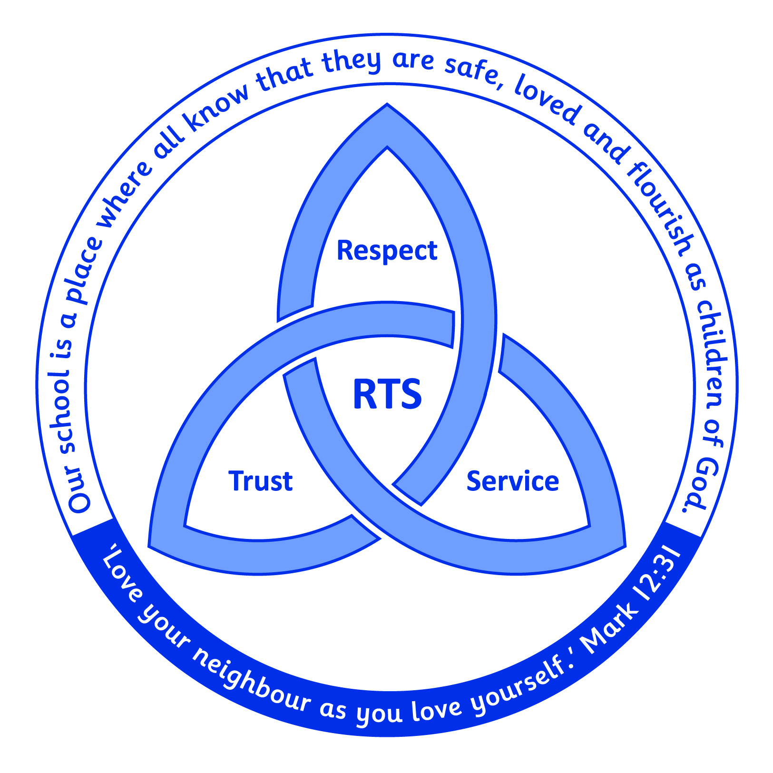

Introduction
The Early Years Foundation Stage (EYFS) refers to children from birth to 5 years old, with the final year usually being the child’s first school year in their Foundation Stage class. The EYFS recognises the developmental stages through which young children progress and identifies the following four principles as paramount to providing each child with the best possible start in life, to fulfil their potential.

The Following principles of the EYFS Statutory Framework, underpin provision and interactions in EYFS:
- A unique child – children’s learning and development profile is unique.
- Positive relationships – secure relationships are the bedrock of learning and development.
- Enabling environment – reflecting interests and developmental levels promotes further learning.
- Learning and development – recognises the interconnection of all areas of learning.

The Foundation Stage Curriculum
This Early Years Foundation Stage (EYFS) is split into 7 areas of learning and development. All areas of learning and development are important and inter-connected. There are three prime areas of learning and four specific areas of learning.
Three prime areas:
- Personal, Social and Emotional Development.
- Communication and Language.
- Physical Development.
Four specific areas:
- Literacy Development.
- Mathematical Development.
- Understanding the World.
- Expressive Arts and Design.

Learning in The Foundation Stage
The EYFS environment is carefully planned to ensure that play is purposeful and supports learning. Alongside child-initiated play, children take part in whole class phonics and maths sessions, adult led group and 1:1 activities. In the EYFS we use the ‘Rocket Phonics’ scheme to develop reading and writing and the ‘NCETM Mastering Number’ program to develop fluency and mastery in number. School values are interwoven through all activities, and a sense of belonging is carefully nurtured.

Parent Partnership
By building positive and respectful partnerships with parents, we aim to ease the transition to school, laying the foundations for children to flourish in the EYFS and beyond. Opportunities to liaise with parents are provided by:

- Pre-school parental consultations.
- Pre-school transition evening.
- Child with parent pre-school visits
- Reading evening and regular phonics drop in sessions
- Half termly stay and play sessions
- Shared worship times
- Two way sharing of learning and development on Tapestry
- Inviting parents in to read with children as ‘secret readers’
- Weekly blog on Tapestry
- Parent consultations Autumn and Spring term

Assessment
Assessment is based on staff observations and interactions with children. Profile assessment using the ‘Development Matters’ assessment points are made on entry and revisited termly. Learning and development is regularly recoded and shared with parents using the Tapestry app. End of year assessments of learning and development as defined by the DfE Early Learning Goals are completed for each area of the EYFS framework. The judgements are as follows:
EXPECTED - at the level of learning and development expected by the end of EYFS.
EMERGING - not yet at the level of learning and development expected by the end of EYFS.
End of year assessments, along with the characteristics of each child’s learning, are shared with Year 1 teachers, ensuring a smooth transition into Key Stage 1.

Equal Opportunities
We aim to provide all pupils, regardless of ethnicity, culture, religion, home language, family
background, learning difficulties, disabilities, gender or ability, equal access to all aspects of school life and work to ensure that every child is valued fully as an individual. Practitioners, as role models, are aware of the influence of adults in promoting positive attitudes and use that influence to challenge stereotypical ideas.

Inclusion
We understand that all children are unique and individual, and we strive to meet the varying needs of each one. Class provision maps are used to identify children’s specific needs in the areas of:
- cognition and learning
- communication and interaction
- emotional, behavioural and social
- sensory & physical
Targets are planned to meet theses needs and additional adult support is provided where appropriate. Class provision maps are reviewed and updated termly. In some instances individual ‘Goals maps’ further identify and support the needs of individuals. Progress is monitored and reviewed regularly. The SEN co-ordinator provides further advice to practitioners and parents and arranges external support where necessary.

Reviewed Feb 2025
Review Feb 2028

