**Principles of Outstanding Science at RTS**

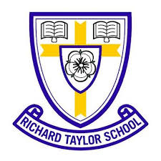

explore and discover

evaluate and interpret

develop knowledge and skills

ask questions and skills



collaborate



arouse curiosity

foster resilience

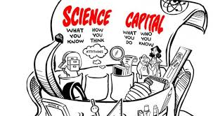

link to real life



relevant

Hands on, Hearts on, Minds on- Learning Inside and Out