


Accessibility Plan
For
Richard Taylor CE Primary School.
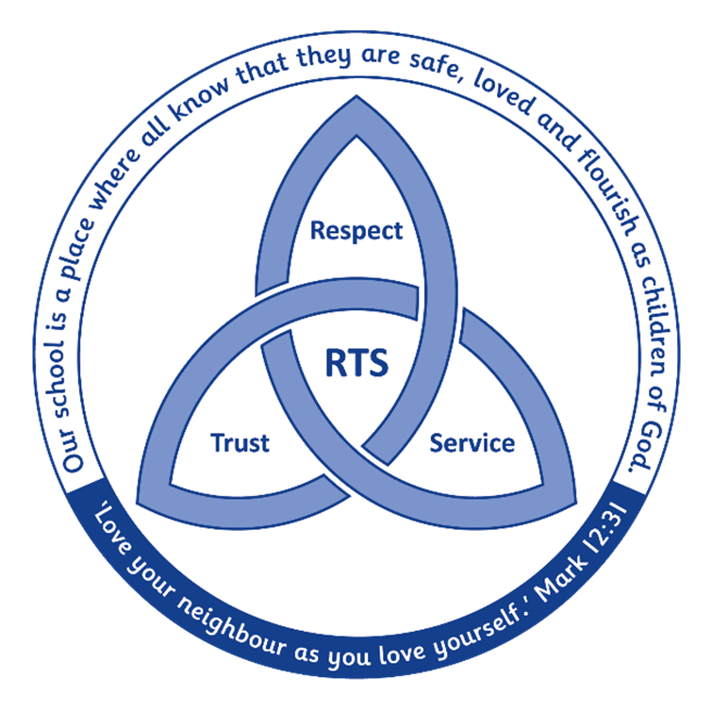

History of document: To be reviewed annually and re-approved every three years, or sooner if deemed necessary.
Issue number | Author | Date written | Approved by LGB | Comments
1 | A Symonds | November 2018 | Spring 2019
2 | A Symonds | February 2022 | Summer 2022
3 | A Symonds | September 2023 | Autumn 2023

1. Aims
Schools are required under the Equality Act 2010 to have an accessibility plan.

Richard Taylor Church of England Primary School plans to ensure the accessibility of provision for all pupils, staff and visitors to the school.

Our Accessibility Plan will be drawn up to cover a three-year period. The plan will be updated annually.

The Accessibility Plan will contain relevant actions to:

Increase access to the curriculum for pupils with a disability, expanding and making reasonable adjustments to the curriculum as necessary to ensure that pupils with a disability are as, equally, prepared for life as are the able-bodied pupils; (If a school fails to do this they are in breach of the DDA). This covers teaching and learning and the wider curriculum of the school such as participation in after-school clubs, leisure and cultural activities or school visits. It also covers the provision of specialist aids and equipment, which may assist these pupils in accessing the curriculum.

Improve access to the physical environment of the school, adding specialist facilities as necessary. This covers reasonable adjustments to the physical environment of the school and physical aids to access education.

Improve and make reasonable adjustments to the delivery of written information to pupils, staff, parents and visitors with disabilities. Examples might include hand-outs, timetables, textbooks and information about the school and school events. The information should be made available in various preferred formats within a reasonable time frame.

We have created an accessibility action plan. It may not be feasible to undertake some of the works during the life of this first Accessibility Plan and therefore some items will roll forward into subsequent plans.

We acknowledge that there is a need for on-going awareness raising and training for staff and governors in the matter of disability discrimination.

Yorkshire Causeway Schools Trust aims to treat all its pupils fairly and with respect. This involves providing access and opportunities for all pupils without discrimination of any kind.
The plan will be made available online on each school website, and paper copies are available upon request.
The Trust is also committed to ensuring staff are trained in equality issues with reference to the Equality Act 2010, including understanding disability issues.

The Trust and its schools support any available partnerships to develop and implement the plan.
The Trust’s complaints procedure covers the accessibility plan. If you have any concerns relating to accessibility in Trust schools, this procedure sets out the process for raising these concerns.

2. Legislation and guidance
This document meets the requirements of schedule 10 of the Equality Act 2010 and the Department for Education (DfE) guidance for schools on the Equality Act 2010.
The Equality Act 2010 defines an individual as disabled if he or she has a physical or mental impairment that has a ‘substantial’ and ‘long-term’ adverse effect on his or her ability to undertake normal day to day activities.
Under the Special Educational Needs and Disability (SEND) Code of Practice, ‘long-term’ is defined as ‘a year or more’ and ‘substantial’ is defined as ‘more than minor or trivial’. The definition includes sensory impairments such as those affecting sight or hearing, and long-term health conditions such as asthma, diabetes, epilepsy and cancer.
Schools are required to make ‘reasonable adjustments’ for pupils with disabilities under the Equality Act 2010, to alleviate any substantial disadvantage that a disabled pupil faces in comparison with non-disabled pupils. This can include, for example, the provision of an auxiliary aid or adjustments to premises.
This policy complies with our funding agreement and articles of association.

3. Action plan
This action plan sets out the aims of our accessibility plan in accordance with the Equality Act 2010.

1.Access to the Curriculum
Continually improving teaching and learning, lies at the heart of the school’s work. Through self-review and Continuous Professional Development (CPD), we aim to enhance staff knowledge, skills and understanding to promote excellent teaching and learning for all children. We aim to meet every child’s needs within our classes. All children have always had access to arrange of after school clubs, leisure and cultural activities and educational visits.

Aim | Current Good Practice | Actions to be taken | Timescale | Responsibility | Success Criteria
1a. To provide more staff  training to meet special  needs. | A number of staff trained in programmes to support inclusive practice | To ensure all support staff are training in supporting an additional aspect of additional need  ELSA/ ADHD/Sensory/ AUTISM/Thrive/Hearing  One staff meeting each term to focus on staff training to support additional need | All training to be  arranged termly | SENDCo & SLT | All staff trained to support a specific area of provision for additional need
1b. To ensure access to simple tools which improve access to curriculum | School beginning to introduce, dyslexia friendly paper, fonts, displays | To undertake an audit with all staff to ensure there is a consistent use of available equipment in all classes and a shared understanding of how they support access to the curriculum | Autumn  term inclusion focus | SENDCo & SLT | School uses equipment and approaches to support access to equipment in a consistent manner.
1c. Ensure out of school activities are planned to ensure access and participation of all pupils | School regularly runs after school sports clubs and participates in sporting competitions. | To review current after school provision to ensure it is being accessed by children with identified additional need.  To develop non-sporting clubs: Chess/Board Games/ Art/ Wellbeing/ Cookery to increase opportunities for participation  Ensure school increases use of YCST minibus to ensure all pupils can access sporting events off site. | 2023-2024 | HT and PE Coordinator | School is running a range of sporting and non-sporting clubs which are accessed by pupils identified as vulnerable
1d. To ensure that all pupils have access to outdoor education opportunities | Forest School Programme is currently being widened to include all pupils in yr1/2  School has a developed wildlife area | Expand Forest school programme, complete curriculum SOW and introduce opportunities to all children | 2023-2024 | Forest School Lead KSh | All children benefit from access to outdoor Forest School education programme
1e. To ensure that approaches to supporting pupil’s mental health and wellbeing are embedded in whole school approach to accessing curriculum | The school has a wellbeing action plan and identified wellbeing ambassadors. We seek to promote 5 ways to wellbeing in every class | To develop the role of wellbeing ambassadors to support pupil wellbeing.  To develop and increase access to ELSA therapy for more children.  To ensure daily curriculum delivery includes actions which support good mental health | Review impact of actions in Autumn term 2023 and identify next steps | Inclusion and Wellbeing Leads  AR & ESt | Good practice in supporting mental health is embedded in daily classroom practice and recognised on provision map.

2. Physical Environment
Richard Taylor Church of England Primary School seeks to ensure that the physical environment provides the best platform for all children to grow, thrive and learn. The school’s premises development plan will be the framework for all actions which improve accessibility for all children.

Aim | Current Good Practice | Actions to be taken | Timescale | Responsibility | Success Criteria
2a To ensure all staff have access to appropriate seating. | Majority of classrooms have access to ergonomic seating for staff | To ensure all staff have access to seating which supports physical wellbeing and posture. | Summer 2022 | AS & SB | All staff have access to appropriate seating.
2b To improve lighting systems in school | School has renovated 40% of identified lighting | To complete further renovation of lighting in hall, kitchen and KS2 classrooms to support visually impaired pupils | 2022-2024 | AS & SB | Lighting Programme completed.
2c To ensure all disability access systems are in place. | School has a disabled parking space and disability toilet. | Renovate markings to disabled access parking space. Undertake audit of disabled access points in school and signage | 2022-2023 | AS & SB | Disability access signage consistent across school
2d Renovate staffroom to improve access and facilities for staff |  | School to complete renovation of staffroom | 2022-2024 | SB | Staffroom supports staff wellbeing
2e. To ensure all pupils with additional physical and cognitive needs can be safely evacuated in event of school evacuation | The school regularly reviews systems for supporting the safe evacuation of pupils with additional needs | Staff to ensure PEEP (personnel emergency evacuation plans) for all identified children have been updated and shared with HT | Autumn 2023 | AS | PEEPs confirm reviewed evacuation plans for identified children,

3.Communication
This will include planning to make written information that is normally provided by the school to its pupils available to disabled pupils. Examples might
include handouts, textbooks and information about school events. The information should take account of pupils’ disabilities and pupils’ and parents’
preferred formats and be made available within a reasonable timeframe.
In planning to make written information available to disabled pupils we need to establish the current level of need and be able to respond to changes in the
range of need. The school will need to identify agencies and sources of such materials to be able to make the provision when required.

Aim | Current Good Practice | Actions to be taken | Timescale | Responsibility | Success Criteria
3a Languages other than  English to be visible  around school. | Welcome signs in entrance do reflect a welcome to school in in various  Languages. | School to audit range of languages in school and reflect diversity in range of signs throughout school in hall, library and classrooms. | 2023-2024 | AS & ESt | All families feel welcome  and have a clear  understanding of school  procedures
3b Information on website accessible to all. | Website reviewed on termly basis against clear criteria. | Ensure website is fully compliant with requirement for access by person with visual impairment.  Ensure guidance on website is clear regarding access to information in different languages. | 2023-2024 | AS/SB/LGB | Website to have very  clear information that can  be accessed by all people.
3c Information for parents/carers to be clear for all | Information shared using a range of formats including text email, tweet, newsletter and blog | To review information sharing with parents to ensure we are sharing the right information in the best format to suit needs of all families | 2023-2024 | AS/SB | School is effective in sharing information which meets needs of families.
3d Ensure all staff are aware of accessible formats. | Staff developing awareness of dyslexia friendly systems for sharing information | Guidance provided to staff on dyslexia and  accessible information. Children provided with appropriate materials. | 2023-2024 | ESt | Staff use dyslexia friendly communication systems in a consistent manner.

5. Links with other policies

This accessibility plan is linked to the following policies and documents:

- Health and Safety Policy
- Equality information and objectives (public sector equality duty) statement for publication
- Special Educational Needs (SEN) information report
- Supporting Pupils with Medical Conditions Policy
- Child protection Policy

Review Document

Access
Physical Environment
Communication

